

**Productivity puzzles**

Speech given by

Andrew G Haldane, Chief Economist, Bank of England

London School of Economics 20 March 2017

The views are not necessarily those of the Bank of England or the Monetary Policy Committee. I would like to thank Sandra Batten, Shiv Chowla, Fergus Cumming, Adriana Fernandes,

Jeremy Franklin, Dena Jacobs, Gabor Pinter, Alex (Sasha) Naumov and Jessica Verlander for their help in preparing the text. I would like to thank Omar Ahmed, Saleem Bahaj, Giuseppe Berlingieri, Phillip Bond, Sara Calligaris, Greg Clark, Chiara Criscuolo, Angus Foulis, Peter Gal, Richard Harrison, David Hendry, Bill Janeway, Casey Murphy, Lukasz Rachel, John Van Reenen, Michael Saunders, Patrick Schneider and colleagues at the ONS Research Database for their comments and contributions.

By common assent, economists do not agree on much. I have lost count of the number of jokes about economists whose punchline ends “and they still couldn’t reach a conclusion”. That is why Harry S Truman, when President of the United States, famously yearned for a one-handed economist. Whether or not this critique is fair, the issue I will discuss tonight is one on which economists *do* agree: productivity matters.

At this point, it is customary to wheel out the following, now rather over-used, Paul Krugman quote: “productivity isn’t everything, but in the long run it is almost everything.” Despite its over-use, this quote does have one important virtue, something not to be taken lightly in this post-fact, post-truth world: it is empirically verifiable and appears to be factually accurate. Let me illustrate that with a simple example.

Since 1850 UK living standards, as measured by GDP per head, have risen roughly 20-fold, a huge gain. How much of that gain can be attributed to higher productivity? Well, if productivity had flat-lined over the period, UK living standards would only have only doubled. Or, put differently, in the absence of productivity growth, UK living standards would be an order of magnitude lower today, stuck at late-Victorian levels.

A more refined way of reaching the same conclusion is to decompose growth into the contribution from inputs into the production process – labour and capital – and the contribution from improvements in the efficiency with which these inputs are used – so-called Total Factor Productivity (TFP). Chart 1 does that for the UK since the Industrial Revolution. This suggests movements in TFP have accounted for the lion’s share of both the growth and variation in living standards since at least the mid-18th century.

Saying that productivity matters is not the same as saying we *understand* its determinants. The past few years have served to underscore just how partial economists’ understanding of productivity remains. As one illustration, Chart 2 plots successive forecasts by the Bank of England of UK productivity growth since 2008, while Chart 3 shows IMF forecasts of productivity across advanced economies over the same period.

These charts point to a string of material and serially-correlated forecast errors over recent years. Productivity growth has consistently underperformed relative to expectations, since at least the global financial crisis. This tale of productivity disappointment, in forecasting and in performance, has been extensively debated and analysed over recent years. Some have called it the “productivity puzzle”.1

With each year that passes, and as each new turning point in productivity has failed to materialise, this mystery has deepened. This has led some to conjecture that the world may have entered a new epoch of sub-par productivity growth, an era of *secular stagnation*.2 Various possible causes of this stagnation have been posited, including adverse demographic trends and diminished rates of innovation.3 The secular stagnation hypothesis is striking in its gloomy implications for future growth in living standards.

1 For example, Barnett et al (2014), Bryson et al (2014) and Weale (2014)

2 For example, Gordon (2014) and Summers (2013).

3 Gordon (2014).

It is striking, too, because of the starkness with which it contrasts with a second topical hypothesis. This posits that we may be on the cusp of a Second Machine Age or Fourth Industrial Revolution, an era of *secular innovation*.4 This might arise from the rise of the robots, artificial intelligence, Big Data, the Internet of Things and the like. Because of its impact on future living standards, the winner of this secular struggle – stagnation versus innovation – carries enormous societal implications.

A second issue, every bit as topical and important, concerns the *distribution* of gains in living standards. Specifically, there has been mounting concern over a number of years about rising levels of within-country inequality across a number of countries.5 Candidate explanations for this widening dispersion in fortunes include failings in the educational system, the impact of technology and globalisation, anti-competitive practices and weaknesses in corporate governance.6

Both of these great debates – innovation versus stagnation, the widening dispersion of income and opportunity across society – have a causative link to productivity. A household’s income depends largely on wages and these wages depend, in turn, on the productivity of the company at which households work. So falling productivity growth among firms, and widening dispersion of productivity across firms, could in theory have contributed to stagnant household incomes and widening dispersion in these incomes.

To be clear up front, I do not have a simple explanation, much less an oven-ready solution, for these productivity puzzles. My aims here are more modest – to draw together some of the available data on productivity to shed light on the puzzles. Specifically, I will look at historical data for the UK, at international data from a cross-section of countries and at sectoral and firm-specific data for UK companies.

This empirical evidence suggests a long tail of countries and companies with low, slow productivity growth. These productivity laggards have been unable to keep-up, much less catch-up, with frontier countries and companies.7 At the same time, an upper tail of companies and countries has maintained high and rising levels of productivity. These productivity leaders are pulling ever-further away from the lower tail. Or, put differently, rates of technological diffusion from leaders to laggards have slowed, and perhaps even stalled, recently.

This empirical pattern sheds light on the two great macro-economic debates. It helps explain why we might see the *co-existence* of secular innovation (among leaders) and stagnation (among laggards). It helps account for the fall in productivity growth rates – namely, slower rates of diffusion of new innovation to the long lower tail of companies. And it helps explain the widening dispersion in households’ incomes, as the mirror-image of widening productivity differences across firms.

4 For example, Brynjolfsson and McAfee (2011, 2014).

5 For example, Piketty (2014), Milanovic (2016).

6 Stiglitz (2016).

7 This has been a key theme of recent work by the OECD, for example Andrews et al (2015).

This empirical prognosis also helps when devising policy measures to tackle these productivity problems. Even marginal improvements to productivity among the long tail of low-productivity companies – or, equivalently, a speeding up of rates of technological diffusion to these companies – could make significant inroads into the productivity puzzle. I will discuss possible policies to do so at the end.

## Explaining the Productivity Puzzle

Before diving into the data, it is helpful to set out some of the candidate explanations that have been used to explain the productivity puzzle, in the UK and internationally. These hypotheses include:

1. *Mismeasurement*

There is a fairly widespread perception that the productivity puzzle may, at least in part, be no more than a statistical mirage. It certainly seems likely that official statistics underestimate economic activity to some, perhaps significant, degree and with it potential productivity gains.8 For example, a recent review concluded that productivity growth in the UK might be under-estimated by around 0.5 percentage points per year, as a result of the failure fully to capture elements of the digital economy.9

That said, most studies have also found that mismeasurement alone is unlikely to account for the majority of the productivity puzzle, whether in the UK or internationally.10 Many of the mismeasurement problems already existed long before productivity started slowing. These problems would need to have increased dramatically – and probably unrealistically – to explain fully the productivity slowdown. Consistent with that, the slowdown in productivity appears to be largely unrelated to the penetration of information technologies across sectors and countries.11

1. *Crisis-related scarring*

There is plenty of evidence to suggest that financial crises can have a permanent, or certainly persistent, scarring effect on output and productivity in economies.12 This time’s crisis, the largest in at least a generation, is unlikely to buck that historical trend. There are several channels through which financial crises might permanently damage corporate sector productivity.

First, a collapse in credit availability is likely to constrict the financing of both new and existing companies and hence constrain their investment plans. It may hit particularly hard young companies, without access to alternative sources of finance, for whom productivity growth is often fastest. Empirical evidence from the

8 For example, Feldstein (2016), Baily and Montalbano (2016).

9 Bean (2016) discusses the potential mechanisms for the underestimation of GDP.

10 Syverson (2016), Byrne et al (2016).

11 Syverson (2016).

12 For example, Reinhart and Rogoff (2009), Oulton and Sebastiá-Barriel (2013).

crisis suggests these channels were potent, in the UK and internationally.13 As credit conditions have eased recently, however, this has become a less compelling explanation for persisting productivity problems.

A second financial channel through which the crisis may have affected firms’ investment is asset prices. Specifically, many small firms are reliant on property collateral to back their loans. A fall in property prices tightens their collateral constraint and credit conditions. Recent Bank of England research has suggested this may have been a potent crisis propagation channel for smaller businesses during the crisis.14 As asset prices have recovered, however, this channel cannot explain the persisting productivity puzzle.

A third channel through which the crisis might have slowed productivity is by hindering resource reallocation between firms and across sectors.15 Flows of capital and labour between companies are one of the key channels through which technology and ideas are diffused.16 Since the crisis, rates of labour market churn between companies have been low and the dispersion in rates of return across sectors has been high.17 Both are consistent with lower rates of factor reallocation having contributed to low productivity.

1. *Forbearance and monetary policy*

Some have contended that productivity may have been held back by the actions of the authorities, in particular regulatory forbearance and accommodative monetary policies. By supporting low-productivity companies who would otherwise have failed, policy actions may have prevented the “creative destruction” of firms.18 Certainly, the level of company liquidations and firm exits has remained low in many countries since the financial crisis, probably lower than would have been expected given the path of GDP.

A number of studies have considered the evidence on the impact of regulatory and monetary policies on firm death and productivity.19 For instance, Arrowsmith et al (2013) examine the prevalence of bank forbearance across the small to medium-sized enterprises (SME) sector, finding the effect to be small. The same study finds a potentially larger impact of monetary policy on company failure and productivity.20 That said, it is important to note that employment was also higher as a result of looser monetary policy, with potentially smaller crisis-related scarring effects on labour markets.

13 Chodorow-Reich (2014), Greenstone and Mas (2012) and Edgerton (2012) for the US, Amiti and Weinstein (2013) for Japan, Paravisini et al (2015) for Peru, Bentotila et al (2013) for Spain and Franklin et al (2015) for the UK.

14 Bahaj et al (2016).

15 Riley et al (2015), Barnett et al (2014).

16 For example, Newman et al (2015), Hoekman et al (2004).

17 Barnett et al (2014), Broadbent (2012), Hseih and Klenow (2008), Calligaris et al (2016).

18 For example, McGowan et al (2017) and Pessoa and Van Reenen (2014).

19 Cette et al (2016), Reis (2013), Gopinath et al (2015) and Gorton-Ordones (2015).

20 See also, Broadbent (2012).

1. *Slowing Innovation*

Some economists believe that the type of technological progress behind productivity growth over the past two centuries may not continue at the same pace in the future.21 One argument is that the current wave of innovation, grounded in ICT, does not have the same potential as past innovations.22 A second is that the ICT revolution is already quite mature and that future progress is likely to be slower.23 A third is that, with world population expected to peak this century, so too might the pace of innovation.24

These arguments are contentious and have been the subject of lively debate.25 Some have argued that the ICT revolution has already had a greater impact on productivity than the steam engine.26 Others have argued that the ICT revolution is still in its infancy and has vast potential for further disruptive innovation.27 And a third contends that there are many emerging technologies with the potential to revolutionise the economy, such as robotics, artificial intelligence, Big Data and the human genome.28

1. *Diffusion Dynamics*

An alternative way of accounting for slower productivity growth is that it arises, not from slower rates of innovation, but from slower rates of *diffusion* of innovation to other companies and countries.29 For example, recent empirical work by the OECD has highlighted the possibility of the technological diffusion engine having slowed, or even stalled, over the most recent period, with a widening in dispersion between the fortunes of those companies operating at the technological frontier and those operating inside this frontier.30

There are a number of possible explanations for such a phenomenon. Stifled competition in certain sectors and for certain products may have prevented the trickle-down of innovation.31 For example, restrictions on patents and intellectual property (IP) might restrict new entrants and retard replication. A related hypothesis is that, in today’s globalised markets, network economies of scale and scope are more potent, generating natural monopolies in which single or small sets of players dominate market share.32

A third hypothesis is that the emergence of a long tail of non-frontier companies, failing to keep pace with innovation, is the result of management failings. For example, Nicholas Bloom and John Van Reenen have shown that weaknesses in management processes and practices go a long way towards explaining the long

21 Gordon (2012) and Cowen (2011).

22 Gordon (2012).

23 Decker et al (2016) argue there has been a fall in entrepreneurship in high tech sectors over recent decades.

24 Gordon (2014). Jones and Romer (2010).

25 See Tuuli and Batten (2015) for a summary of this debate.

26 Craft (2004).

27 Brynjolfsson and McAfee (2011).

28 Mokyr (2014a and 2014b) and Baily et al (2013).

29 Comin and Hobijn (2010).

30 Andrews et al (2015).

31 Andrews et al (2015).

32 For example, Haskel and Westlake (2016).

tail of low productivity manufacturing companies.33 These poor practices are most pronounced in sectors where competition is weak and in family-owned firms where management control rests with the eldest son. The data presented below do not, in the main, allow a direct empirical test of these competing hypotheses. Many of these hypotheses are, in any case, complementary explanations. The data do, however, lend greater weight to some, and less to other, of these explanations when accounting for the productivity puzzle.

## Historical Productivity Trends

Let me start by placing the UK’s recent productivity performance in a broader historical context. That is useful for determining just how unusual the recent period of sub-par productivity performance really is.

Since the Industrial Revolution, GDP per capita in the UK has risen almost without interruption, at an annual average rate of 1.2% per year. In lockstep, there has been a near-monotonic rise in UK productivity. UK TFP growth since 1750 has averaged 0.8% per year. Since the Industrial Revolution, GDP per capita has doubled roughly every 65 years and productivity roughly every 85 years.

The implications for living standards have been profound. Each generation has, since the Industrial Revolution, been around 25% better off than their parents. This is a story of secular improvements in living standards. It is also a story of secular innovation, with the two typically going hand in hand. At least over recent centuries, secular stagnation in living standards and innovation has simply not fit the historical facts.

This is not, however, the whole story. For a longer-term perspective, Chart 4 shows an estimate of UK TFP back to 1 AD, alongside GDP per head. The measurement problems in GDP and productivity were probably more acute then than now. Nonetheless, the “hockey-stick” profiles of both GDP and TFP are striking, both in their own right and in their similarity. Over the long haul, GDP and TFP have moved in lockstep.

For many centuries prior to the Industrial Revolution, productivity and GDP growth in the UK averaged only around 0.01% per year. Each generation was only around 0.3% better off than their parents – a scarcely noticeable improvement. Secular stagnation in living standards and innovation persisted for many centuries. History suggests both secular innovation and secular stagnation have, at different times, been the norm.

Although productivity growth has picked up since the Industrial Revolution, it has still been subject to significant twists and turns. Chart 5 plots UK labour market productivity since 1760, decomposed into the contribution from additional capital per worker (“capital deepening”) and TFP. Both have fluctuated significantly and have made substantial contributions to UK productivity growth over time.

33 Bloom and Van Reenen (2007).

Chart 6 looks more closely at the historical evolution of UK TFP growth. Trends in TFP have been far from constant, with decadal spans when productivity has averaged little more than zero and others where it has averaged close to 2%. The latter episodes have typically been associated with periods of rapid technological change, as after the three industrial revolutions of the mid-18th, mid-19th and mid-20th centuries.

In each case, there was a significant lag between the arrival of new technologies and their impact on productivity. Rates of technological diffusion were relatively slow and sedate. This is typically felt to have reflected the time it takes for new technologies to find widespread use and become General Purpose Technologies (GPTs).34 After the first Industrial Revolution, it took around 70-100 years for technological diffusion to occur, GPTs to emerge and TFP and living standards to rise.35

Subsequent industrial revolutions have also seen a lag between the emergence of new technologies and their impact on productivity. But there is evidence this diffusion lag may have shortened. Comin and Mestieri (2014) estimate the diffusion lag during the industrial revolutions of the late 19th and 20th centuries to have been 20-30 years, roughly a third of that during the first industrial revolution. This may have reflected increased flows of labour, capital, ideas and information between firms, regions, sectors and countries.

Table 1 looks at average rates of UK TFP growth over the past 2000 years. It tells a tale of long waves of productivity stagnation and innovation. The historical data do not reject either hypothesis. Table 1 also puts into historical perspective the UK’s recent productivity slowdown. For the past decade, average productivity growth has been *negative*. This is unusual, if not unique, historically. You would have to go right back to the 18th century to see a similarly lengthy period of stagnant productivity.

## Global Productivity Trends

If UK productivity patterns are unusual relative to the past, how unusual are they relative to other countries? To assess that, I draw on a panel of around 116 countries, advanced and emerging, going back to 1950, using data from the Penn World Tables.36 Chart 7 plots average TFP growth across the whole sample of countries, while Chart 8 does so separately for advanced and emerging economies. Several interesting features emerge.

First, the slowdown of productivity growth has clearly been a *global* phenomenon, not a UK-specific one. From 1950 to 1970, median global productivity growth averaged 1.9% per year. Since 1980, it has averaged 0.3% per year. Whatever is driving the productivity puzzle, it has global rather than local roots.

34 Helpman et al (1998).

35 Comin and Mestieri (2014).

36 Feenstra et al (2015).

Second, this global productivity slowdown is clearly not a recent phenomenon. It appears to have started in many advanced countries in the 1970s.37 Certainly, the productivity puzzle is not something which has emerged since the global financial crisis, though it seems the crisis has amplified pre-existing trends.

Explanations for the productivity puzzle based on crisis-related scarring are likely to be, at best, partial.

Third, the productivity slowdown has been experienced by both advanced and emerging economies. The slowdown in median productivity growth after the 1970s among both advanced and emerging market economies is around 1¾ percentage points (Chart 8). Indeed, looking at country-specific trends, it is striking just how generalised the productivity slowdown has been (Chart 9).

Fourth, one way of understanding this global productivity slowdown comes from decomposing it into changes in rates of *innovation* among countries operating at the productivity frontier and changes in rates of *diffusion* from frontier to non-frontier countries. Growth theory would predict that, over time, technological diffusion should lead to catch-up between frontier and non-frontier countries.38 And the greater the distance to the frontier, the faster these rates of catch-up are likely to be.

So what explains the 1¾ percentage point slowdown in global productivity growth since the 1970s – slower innovation at the frontier or slower diffusion to the periphery? If the frontier country is taken to be the United States, then slowing innovation can only account for a small fraction of the global slowing, not least because the US only has about a 20% weight in world GDP. In other words, the lion’s share of the slowing in global productivity is the result of slower diffusion of innovation from frontier to non-frontier countries.

To illustrate that, Chart 10 plots the distribution of levels of productivity across countries over a set of sample periods, where productivity is measured relative to a frontier country (the United States) indexed to one.

Comparing the distributions in the 1950s and 1970s, there is a clear rightward shift. Cross-country productivity convergence or catch-up was underway, as the Classical growth model would suggest.

In recent decades, however, that pattern has changed. Comparing the 1970s with the 1990s, there is a small *leftward* shift in the probability mass. And in the period since the global financial crisis, there has been a further leftward shift in the distribution and a widening of its range. Today, non-frontier countries are about as far from the technological frontier as they were in the 1950s.

Another way of illustrating the same point is by looking at differences in productivity between frontier and periphery countries over time (Chart 11). In the decades immediately following the Second World War, the Classical growth model was operating effectively, with catch-up in productivity underway and at faster rates among emerging market countries with furthest to travel to the frontier.

37 Gordon (2014).

38 Barro and Sala-i-Martin (1992) and Rodrik (2011).

Since the 1980s, however, that convergence process appears to have stalled, perhaps even to have gone into reverse, in both advanced and emerging economies. The gap to the frontier has failed to close and, in particular for emerging market countries, has widened. Classical growth dynamics appear for some reason to have stopped operating, with the gap to the frontier widening the more so the greater the distance to it.

It is possible to quantify this slowing in convergence using a similar approach to that used to measure output convergence in the cross-country growth literature.39 Specifically, a country’s productivity growth can be linked by a convergence parameter to its productivity gap to the frontier country. This parameter can be estimated econometrically and tracked over time.40

Chart 12 shows a time-series of this convergence coefficient estimated using a rolling regression. In the 1980s, this coefficient averaged 0.8. That is to say, every 10 per cent productivity gap relative to the frontier country resulted, on average, in productivity growth being 0.8 percentage points higher than in the frontier country. By 2000, that convergence coefficient had roughly halved. By the end of the sample, the coefficient is statistically insignificant from zero. Convergence had not just slowed but stalled.

One of the key determinants of international technology transfer has been found to be cross-border flows of goods and services, people and money and capital.41 While they have waxed and waned historically, all of these have tended to rise rapidly since the middle of the 20th century. Other things equal, that would have been expected to *increase* the speed of diffusion of innovation across countries over that period. In practice, the opposite appears to have occurred.

Taken at face value, these patterns are both striking and puzzling. Not only do they sit oddly with Classical growth theory. They are also at odds with the evidence of history, which has been that rates of technological diffusion have been *rising* rather than falling over time, and with secular trends in international flows of factors of production. At the very time we would have expected it to be firing on all cylinders, the technological diffusion engine globally has been misfiring. This adds to the productivity puzzle.

## Sectoral Productivity Trends

Some further insight into these puzzles comes from looking at the productivity data in more granular detail.42

We start by considering sectoral patterns of productivity among UK companies.

Sectoral shifts in the economy could plausibly account for some of the fall in productivity growth. There has been a secular shift over time away from manufacturing and towards services, with the employment share in

39 Rodrik (2011).

40 Based on the following equation: 𝑃𝑖𝑡 − 𝑃𝑓𝑡 = 𝑎𝑖 + 𝑏𝑖 ∗ 𝐺𝐴𝑃𝑖 where 𝑃𝑖𝑡 is growth in TFP for country i in year t, Pft is the growth in TFP

for the frontier country (US) in year t, GAPi is the gap between the level of TFP in country i and the US as a percentage, ai is a constant capturing the average pace of convergence and bi captures how much of the speed of convergence depends on the TFP gap.

41 For example, Hoekman et al (2004), Stoyanov and Zubanov (2012) and Newman et al (2015).

42 See McCafferty (2014) for a discussion of productivity from a sectoral perspective.

manufacturing having fallen from 17% to 7% since 1990. Because productivity growth in manufacturing is higher than in services, this shift could plausibly account for some of the fall in aggregate productivity growth. Even if we correct for this compositional effect, however, the slowdown in UK productivity growth remains.

Chart 13 looks at the evolution of different UK sectors’ productivity, while Table 2 looks at the contributions of various sectors to UK productivity growth in the decades either side of the global financial crisis. Pre-crisis, the strongest rises in measured productivity were in manufacturing, information and communication and financial services, all of which experienced annual growth of over 4%. But growth was not confined to these sectors, with virtually all sectors making a positive contribution to productivity growth.

In the period since the crisis, those pre-crisis trends have changed dramatically. Virtually every sector has seen productivity flat-line. The contributions of all sectors to productivity growth have fallen and most are tightly bunched around zero (Table 2).43 Whatever has caused UK productivity growth to fall, it has done so on a generalised, cross-sector basis.

It is sometimes asserted that, without the collapse in financial services output associated with the financial crisis, the UK’s productivity performance would have held up. It is certainly true that financial sector productivity was probably over-stated in the run-up to the crisis.44 Nonetheless, the subsequent sharp fall in financial services productivity is plainly not the whole story. Of the 1.7 percentage point fall in the UK’s productivity growth since 2008, less than a third can be accounted for by financial services (Table 2).

One sectoral story that could account for this generalised slowing is a reduced rate of factor reallocation between sectors.45 Consistent with that hypothesis, the dispersion of productivity *across* industries has increased significantly over the last 40 years. And the variance in sectoral productivity gaps, relative to pre-crisis trends, also increased sharply after the crisis (Chart 14).

Nonetheless, this pickup in the dispersion of productivity across sectors is dwarfed by the increase in productivity dispersion *within* sectors (Chart 15). This suggests that any obstacles to the movement of resources within the economy have been more important *within* sectors than across them. With that in mind, it is firm-by-firm data to which we now turn.

## Firm-level productivity trends

A more granular lens still comes from looking at firm-by-firm productivity data. The OECD has recently undertaken extensive analysis using company-level data to assess global productivity patterns.46 We draw on two datasets for the UK that can prospectively shed light on firm-level trends.

43 See Billet and Schneider (2016) for an interactive tool for examining sectoral productivity trends.

44 Haldane et al (2010).

45 Bank of England (2016), Barnett et al (2014).

The first is based on the UK Office for National Statistics (ONS) Annual Business Survey and employment surveys.**47** The ONS combines these surveys in the form of the Annual Respondent Database (ARDx). The sample covers around 40,000 companies per year, accounting for around 80% of UK GDP. The data covers the period 2002 to 2014. This survey is stratified to match the UK population of companies and so should be broadly representative of aggregate UK trends.

The second is the Bureau van Dijk (BvD) FAME database, compiled from UK company accounts. Whereas larger firms are required to submit full annual accounts, there are exemptions for smaller firms. So the sample is smaller, at around 20,000 firms per year, and is biased towards larger firms. However, it contains detailed data on firm-level characteristics which are useful when exploring the determinants of productivity.

These data enable us to examine the distribution of productivity across firms. Chart 16a plots this distribution in 2014, based on the ONS data.48 It is wide and elongated, with a long, thin upper tail of high-productivity firms and a short, fat lower tail of low-productivity firms. This shape means that modal productivity among UK companies is around 50% lower than mean productivity.49

One interesting question is how this distribution has evolved over time. Chart 17 looks at different percentiles of the firm-level productivity distribution over time, both in levels terms and indexed to 2002=100. There has been a widening dispersion in the distribution of productivity across companies over time. In particular, there is a striking and widening divergence between frontier firms (say, the 99th percentile of firms) and the long tail of non-frontier companies.

If we define frontier firms as the top 5% of firms by productivity performance, in line with the OECD, there is clear and widening blue water between frontier and laggard companies (Chart 18). In arithmetic terms, it is non-frontier companies that largely explain flat-lining productivity over recent years (Chart 19).

These dynamics cast the secular innovation versus stagnation debate in an interesting light. The distribution of UK companies’ productivity suggests both forces have been operating, albeit at different points in the distribution – innovation in the upper tail, stagnation in the lower one. Widening productivity dispersion means that secular innovation and stagnation are complementary, not competing, hypotheses.

For a relatively small cohort of frontier companies, secular innovation is clearly evident, with both high and rapidly-rising levels of productivity. For example, around 1% of UK firms have seen average productivity growth of around 6% per year. This poses a serious challenge to the notion that stalling innovation has been

46 For example, Andrews et al (2015).

47 This work contains statistical data from ONS which is Crown Copyright. The use of the ONS statistical data in this work does not

imply the endorsement of the ONS in relation to the interpretation or analysis of the statistical data. This work uses research datasets which may not exactly reproduce National Statistics aggregates.

48 The BvD data delivers a similarly-shaped distribution.

49 Other authors finding a long tail of low-productivity companies in the UK include Bloom and Van Reenen (2007).

the key driver of the productivity slowdown. At the same time, for a large cohort of non-frontier companies secular stagnation is evident, with low and flat-lining levels of productivity. For example, around one-third of UK companies have seen no rise in productivity throughout this century. This is a long tail.

A second implication of these results, consistent with the cross-country evidence, is that rates of technological diffusion from frontier to non-frontier companies appear to have slowed. It is stalling diffusion, rather than stifled innovation, that accounts for the UK’s productivity puzzle. These patterns are not unique to the UK. They are shared by a number of other countries internationally. That has led the OECD to conclude that the technological diffusion engine among companies appears to have broken.50

A comparison of the UK with other advanced countries suggests that both the degree of dispersion in productivity performance is larger in the UK, and that this dispersion has widened more in the UK, than in other countries. The dispersion of services sector productivity is more than 50% higher in the UK than in other advanced economies (Chart 20a). It has also widened by materially more in the UK. Even in a world of long and lengthening tails of low-productivity companies, the UK is a striking outlier.

One potential explanation for this longer tail of UK companies than elsewhere is poor management practices. Using the database developed by Bloom and Van Reenen (2007), we can plot a normalised distribution of management skills for a subset of UK firms.51 This suggests (a lack of) management quality is a plausible candidate explanation for the UK’s long tail of companies, as Bloom and Van Reenen find (Chart 21).

Looked at quantitatively, there is a statistically significant link between the quality of firms’ management processes and practices and their productivity. And the effect is large. A one standard deviation improvement in the quality of management raises productivity by, on average, around 10%. This suggests potentially high returns to policies which improve the quality of management within companies.

## Decomposing the Distribution

We can go further in uncovering some of the characteristics of the companies in the upper and lower tails. Might they simply reflect sharp regional differences in productivity, with frontier companies clustered in some regions and laggards in others? Might it simply reflect some sectors, such as manufacturing, generating higher levels of productivity and sitting in the frontier while others, such as services, occupy the lower tail?

Charts 22a to 22f look at different cuts of the data according to: (a) the UK *region* in which the company is based; (b) the *sector* in which the company operates; (c) whether the company *exports* overseas;

1. whether the company is *foreign-owned*; (e) whether the company has introduced *new products and processes* in the preceding three years; (f) the *size* of the firm; and (g) the company’s *leverage*.

50 Andrews et al (2015).

51 With thanks to John Van Reenen for making these data available to us.

Beginning with the regional picture, it is well-known that there are sharp differences in average productivity across UK regions.52 For example, the UK’s highest productivity region (London) is around 75% more productive than its lowest (the North East). Nonetheless, if we look at the regional distribution of productivity, the similarities are more striking than the differences (Chart 22a). Every region has the same long, thin upper tail of frontier companies and a short, fat lower tail of laggard firms.

It is true, as a matter of arithmetic, that the upper tail of frontier companies is somewhat larger, and the lower tail of laggards shorter, in London than in, say, the North East. But the key point is that every region has plenty of both types of firm. Regional differences are not the main factor explaining the UK’s long tail of firms nor why this tail is longer in the UK than elsewhere.

Second, the same is true, by and large, if we move from regions to sectors. There are some reasonably marked differences in average levels of productivity across sector. For example, manufacturing is on average around 35% more productive than construction. Nonetheless, these differences are dwarfed by variations *within* each sector (Chart 22b). Each has a long, thin upper tail and a short, fat lower tail.

Whatever is driving slower rates of technological diffusion, sector-specific technologies are not it.

Third, if we look at the external-facing profile of firms, we begin to uncover some important differences (Chart 22c and d). Firms which export have systematically higher levels of productivity than domestically-oriented firms, on average by around a third. The same is true, even more dramatically, for foreign-owned firms. Their average productivity is twice that of domestically-oriented firms.

This is not altogether surprising. Firms that export are likely to be exposed to global competition and many are integrated into global supply chains. This increases incentives to boost efficiencies and to match international best practices.53 The self-same forces are likely to be at play among foreign-owned firms. The productivity benefits these external-facing firms bring underscore the importance of openness to trade and foreign direct investment in generating rising productivity and living standards over time.

We can quantify these benefits by looking in more detail at the relationship between firms’ productivity and their export share (Chart 23). There is a positive and statistically-significant relationship. Every 10 percentage point increase in a company’s export share of turnover is, on average, associated with a 3% increase in productivity. While causation could operate in either direction, this illustrates the productivity benefits of a corporate sector which is open to trade and exposed to external competition and innovation.

Chart 22e classifies firms according to their spending on new products and processes. The differences here are not especially surprising, with average productivity around 20% higher among firms investing in new

52 For example, Haldane (2016).

53 Newman et al (2015).

products and processes. Nonetheless it is striking, and perhaps surprising, these differences are not larger. Clearly, they do not explain most of the productivity differences across companies.

Firm size appears to matter somewhat more to productivity (Chart 22f). For example, for small firms (with fewer than 50 employees) the picture is a nuanced one. In general, their average levels of productivity are materially lower than for larger firms, on average around 7% lower. There is, in particular, a larger lower tail of small companies with low, or even negative, levels of productivity.

Nonetheless, some smaller companies do inhabit the high-productivity, upper tail. Moreover, small companies tend to exhibit faster rates of productivity growth than larger firms, even when it is from a lower base. Table 3 looks at average productivity growth rates among firms of different size. Smaller firms have higher average growth rates, and greater dispersion in these growth rates, than larger ones.

Finally, when it comes to companies’ leverage, the picture is also a nuanced one.54 High leverage is a characteristic of firms with two very distinct productivity profiles (Chart 22g). Very low-productivity firms tend to have high leverage because their profits, repayment capacity and investment are low. But high leverage also characterises high-productivity firms, whose profits, borrowing and investment are high.

These patterns provide an explanation for the damaging impact of the crisis on productivity growth. The absence of credit may have affected disproportionately high leverage, high productivity companies operating in the upper tail. The distribution of debt is also important when gauging what impact monetary policy and regulatory forbearance may have had on the *lower* tail of companies, to which I now turn.

## The Role of Monetary Policy

These distributional data enable us to look closely at the lower tail of companies who have potentially been protected from failure since the global financial crisis by regulatory forbearance and accommodative monetary policies. Chart 16b plots this lower tail on three dates, pre-crisis (2002), mid-crisis (2008) and post-crisis (2014). Unsurprisingly, the crisis fattened the lower tail.

Since the crisis, however, this tail has shrunk again. The tail of low-productivity companies today is, if anything, smaller than it was pre-crisis. On the face of it, that is not easy to square with (regulatory and monetary) policies having had a significantly damaging impact on aggregate productivity by keeping alive a large tail of low-productivity companies.

However, these distributions cannot by themselves identify the role monetary policy has played in influencing companies’ fortunes. To gauge that, we need to undertake a counter-factual exercise. Specifically, we

54 Bahaj, Foulis, Gal and Pinter (2016).

consider a simple scenario in which Bank rate is held at 4.25% rather 0.25%. What impact would that have had on companies’ solvency and hence on aggregate productivity?

With data on their debts, interest payments and profits, we can simulate interest cover ratios for each company in our sample – that is to say, their profits before interest divided by interest paid (Chart 24). And by making an assumption about the level of the interest cover ratio at which a company is forced to default, we can simulate how a different interest rate path might have affected the solvency of each firm and hence aggregate productivity.

For the purposes of the experiment, we assume a default threshold for the interest cover ratio of one. That is to say, we assume a company that cannot cover its interest payments with profits fails. Different assumptions are clearly possible. The effect of higher interest rates is to shift the distribution of companies’ interest cover ratios to the left, so that a number of them now lie below the solvency threshold. In the simulation, an extra 10% of companies go bankrupt. This would translate into an immediate loss of around 1½ million jobs – a very significant macro-economic cost.

Nonetheless, there are also prospectively productivity benefits. The scale of these benefits depends on the productivity characteristics of those firms going bust and specifically on their levels of debt. As Chart 25 shows, there is a U-shaped relationship between firms’ productivity and debt, with both high-productivity (“gazelles”) and low-productivity (“zombie”) companies having high debt ratios. Higher interest rates hit both types of company and so the net effect on productivity is an empirical question.

If we assume all firms have the same solvency threshold, more of the firms going bust are zombies than gazelles – there is more creative destruction than destructive destruction (Chart 24c). Nonetheless, the positive impact of higher interest rates on aggregate productivity is significantly tempered by the bankruptcy of some high-leverage, high-productivity companies. The overall effect of higher interest rates in the simulation is to boost the level of productivity by around 1 or 2% relative to the baseline.

This is a significant productivity gain. At the same time, it does not account for the majority of the productivity shortfall since the crisis. Moreover, it comes at a hefty employment cost. Should monetary policymakers have sacrificed 1 ½ million jobs for the sake of an extra 1 or 2% of productivity? Hand on heart, I can tell you this one would not knowingly have done so.

Of course, this experiment is only illustrative and is based on a number of simplifying assumptions. For example, it assumes there is no adverse effect on the output of firms who do not go bust but who nonetheless find their cashflows squeezed. This would tend to raise the output and employment cost of higher interest rates and make the terms of trade for productivity improvements less favourable still.

Acting in the opposite direction, gazelle firms may be able to borrow to avoid bankruptcy in the event of higher interest rates – their solvency threshold might be higher than for zombie companies. If we assumed instead that only the lowest-productivity firms went bust, the boost to productivity is around 3% (Chart 24d). This is more material, but would still need to be weighed against the significant output and employment cost. **The Dispersion of Productivity and Wages**

A final use to which the distributional data can be put is to analyse whether rising dispersion in productivity among firms is mirrored in rising dispersion of wages among households. Have productivity differences been a contributor to rising income inequalities? This has been the subject of a number of recent empirical studies, which have tended to find productivity to have been a significant factor.55

A useful starting point is the distribution of wages across our panel of firms (Chart 26). There is some evidence of a widening dispersion in wages across companies over time. The pattern broadly mirrors productivity, with wages among the top 1% of companies rising, except immediately after the financial crisis. At the same time, pay has largely stagnated among as many as three-quarters of the firms in the distribution.

By itself, this does not tell us how closely firm-level pay and productivity have been correlated and what contribution productivity may have played in widening the dispersion of wages.56 While there is an established literature on the aggregate relationship between productivity and wages, the relationship between firms’ productivity and average pay levels is less certain. Nevertheless, looking at the distributions of pay and productivity, three points stand out (Chart 27).

First, labour productivity can explain around 60% of the variation in average pay across firms, controlling for other firm characteristics. On average, firms with 1% higher productivity have 0.2% higher pay. And firms with 1 percentage point faster productivity growth have 0.5 percentage points faster wage growth (Table 4). Productivity dispersion across companies is an important, if by no means the only, driver of wage dispersion across households.

Second, the distribution of pay is materially narrower than for productivity. The reason for this is that a significant part of firm-specific variation in productivity is absorbed by firms in their profits or reflected in their prices. The reason is that firms’ profits and prices absorb a significant part of firm-specific variation in productivity. Many of the workers in the more productive tail of firms are being underpaid relative to their average productivity, which results in frontier firms making a larger profit share. The opposite is the case at the other end of the productivity distribution.

55 For example, Furman and Orszag (2016)

56 There is time series evidence to suggest a strong historical relationship between aggregate productivity and real wages. For example, Castle and Hendry, Blundell et al (2013) and Disney et al (2013).

This analysis focusses on differences in pay across firms. But what about pay *within* firms?57 We can examine this by tracking differences between the average pay in each company and the pay of their highest paid director. Chart 28 plots the median across firms of these series over time, while Chart 29 compares the variance of each series as well as the gap between average pay and the highest paid director.

Since 1998, the variance in average pay and director pay has increased across firms, although it has fallen notably since the financial crisis. The median gap between average pay and director pay has followed a similar pattern. Although these data are far from perfect they suggest that, while within-firm pay differentials have accounted for some of the increased dispersion in pay across households, across-firm variations have made a larger contribution.

## Tackling the Productivity Puzzle

There has been no shortage of public policy ideas over recent years for boosting productivity growth. Reports by the IMF and OECD have suggested measures ranging from increased infrastructure spending to improved education and training programmes.58 Earlier this year, the UK Government issued a Green Paper setting out various pillars to support productivity.59 And, most recently, here at the LSE the Growth Commission produced their second report on measures to boost UK productivity.60

In generic terms, these policy measures fall into three categories. First, there are measures which support all companies, irrespective of sector, region or characteristic. For example, last year’s Autumn Statement provided additional financial support for UK infrastructure spending, while in the Budget a couple of weeks ago the UK government announced plans for increased support for technical skills.

Second, there are measures which support technological innovation – the creation and growth of frontier firms. One potentially important micro-economic measure supporting innovation is greater recognition of the importance of companies’ *intangible* assets, such as intellectual property (IP). These constitute an increasing fraction of companies’ total assets, but are not measured or valued in as consistent and coherent a way as tangible assets such as plants and machinery.

This can have real costs for the companies concerned. It means these assets are often not valued fully by investors and lenders. This raises the cost of capital for these firms to sub-optimally high levels – a market failure. Remedying that market failure, by ensuring intangible assets are consistently and coherently valued, is important if these companies are to grow to reach their full potential.61

57 For example, Song et al (2015) find that virtually all the rise in earnings dispersion between workers is accounted for by increasing dispersion across the average wages paid by different firms.

58 Andrews et al (2015) and Dabla-Norris et al (2015).

59 HM Government (2013).

60 Aghion et al (2017).

61 Big Innovation Centre (2017b).

More broadly, it is possible that current UK corporate governance practices may act as a brake on innovative companies. A recent report by the Big Innovation Centre makes important proposals for re-purposing UK companies to support long-term investment and productivity.62 The government recently initiated a Patient Capital Review to explore how best to support the financing of innovative companies as they scale-up.63

A third category of policy measure focusses on the fortunes, not of innovative frontier companies, but the long tail of low-productivity non-frontier firms. These companies have tended to be focussed on somewhat less historically. Indeed, their large numbers and disparate characteristics may be one reason why this is the case. Yet given their scale, the returns to modest improvements in these firms could be dramatic.

As a thought experiment, imagine productivity growth in the second, third and fourth quartiles of the distribution of UK firms’ productivity could be boosted to match the productivity of the quartile above. That sounds ambitious but achievable. Arithmetically, that would deliver a boost to aggregate UK productivity of around 13%, taking the UK to within 90-95% of German and French levels of productivity respectively.

The policy question is how to effect those improvements. One idea which offers real potential comes from the Productivity Commission chaired by Sir Charlie Mayfield.64 This starts from the assumption that not only is there a long tail of companies, but that many are unaware of that fact. For the same reason most

car-owners believe they are above-average drivers, most companies might well believe they have above-average levels of productivity.

In fact, we know most companies have *below*-average levels of productivity and a large fraction of them have seen no productivity improvement for several decades. The Mayfield Commission aims to create an app which enables companies to measure their productivity and benchmark themselves against other companies operating in similar sectors and regions.

By shining a light on companies’ relative performance, the aim is that this would serve as a catalyst for remedial action by company management. Indeed, the aim is to provide firms not only with a means of benchmarking themselves, but with tools to improve performance along identified areas. These online tools would be a mechanism for speeding-up the process of technological diffusion to the long tail.

One practical way of doing so is by pairing up companies, frontier and non-frontier, to enable the sharing of best practices. This is effectively a mentoring scheme for firms, the like of which is already common among individuals. What would be in it for frontier companies? A more productive supply chain is clearly in their interests. The public sector could also play a useful nudging role in its procurement practices.

62 Big Innovation Centre (2017a).

63 HM Treasury and Department for Business (2017).

64 Mayfield (2016).

A more ambitious idea still, which I have been considering with Philip Bond, is to develop a virtual environment which would enable companies to simulate changes to their business processes and practices. These platforms are already used by many frontier firms to assess the impact of new technologies and processes on their business. These tools can be created, and tailored to companies’ circumstances, at relatively low cost. This makes them a potentially cost-effective way of facilitating diffusion to the long tail.

Policy measures such as these are valuable in boosting living standards and narrowing the dispersion of incomes across households. As a by-product, they also potentially offer benefits to monetary policymakers. Structural measures to boost investment will tend to raise the interest rate in the economy which equilibrates investment opportunities and savings plans. This is sometimes known colloquially as r*.

Policies which boost r* mean that a given interest rate is likely to impart greater stimulus. Or, put differently, they mean the same level of demand in the economy can be achieved with a higher interest rate. And a “pivot” in the mix of policies, with somewhat less of a contribution from monetary policy and more from structural policies, would probably be desirable. Not least, it could help mitigate any adverse impact of accommodative monetary policies on productivity or the distribution of income and wealth.

## Conclusion

Productivity is a gift for rising living standards, perhaps the greatest gift. It is not, however, one that always keeps on giving, as recent events attest. Whether in supporting living standards, or in shrinking their distribution, tackling the global productivity puzzle is among the most pressing public policy issues today.

If history is any guide, there is unlikely to be any single measure which puts productivity growth back on track. But measures which support the long tail of companies, currently operating at low levels of productivity, have the potential to do considerable good.

As Olympic athletes have shown, marginal improvements accumulated over time can deliver world-beating performance. Applying those marginal gains to the population of UK companies could significantly improve UK living standards, even if those are harder to measure than gold medals.

# Annex

## Chart 1: Decomposition of long run UK GDP growth

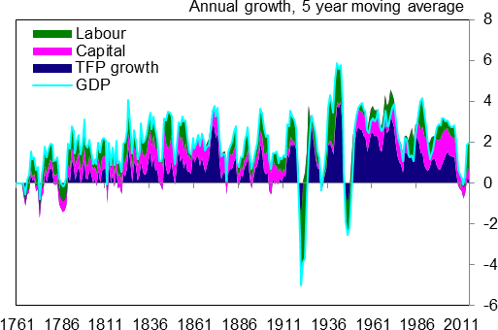

Source: Hills, Thomas and Dimsdale (2016) “Three Centuries of Data - Version 2.3”, available [here.](http://www.bankofengland.co.uk/research/Pages/onebank/datasets.aspx)

## Chart 2: UK labour productivity growth forecast revisions

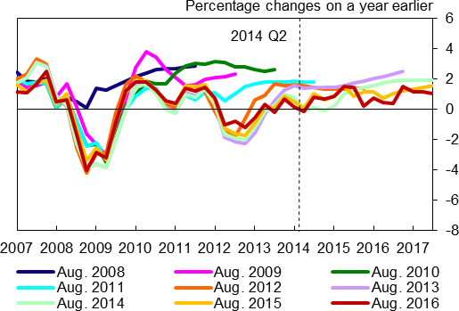

Sources: ONS and Bank of England *Inflation Report* projections. Notes: Forecasts for hourly labour productivity.

## Chart 3: IMF advanced economy labour productivity growth forecast revisions

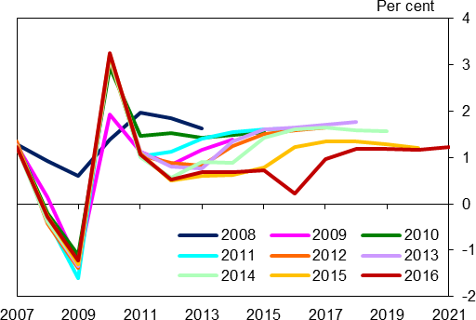

Sources: IMF and Bank calculations.

Notes: Forecasts for productivity per worker.

## Chart 4: Long run UK total factor productivity

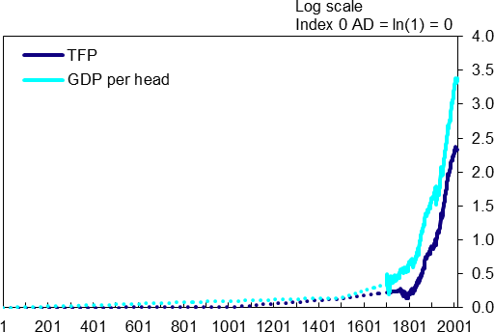

Sources: Hills, Thomas and Dimsdale (2016) “Three Centuries of Data - Version 2.3”, available [here.](http://www.bankofengland.co.uk/research/Pages/onebank/datasets.aspx)

Illustrative estimates prior to 1850 are based on data on the growth rate of technology between 1AD and 1750AD in “A farewell to Alms” by Gregory Clark.

## Chart 5: Decomposition of long run UK labour productivity growth

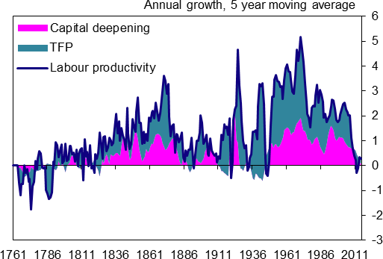

Sources: Hills, Thomas and Dimsdale (2016) “Three Centuries of Data - Version 2.3”, available [here.](http://www.bankofengland.co.uk/research/Pages/onebank/datasets.aspx)

## Chart 6: Long run UK total factor productivity growth

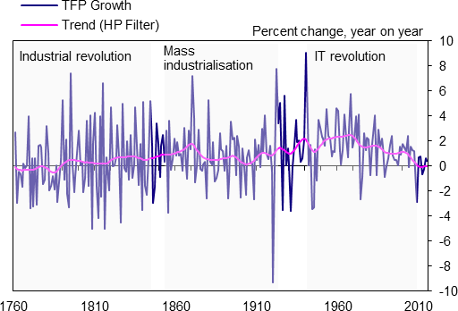

Sources: Hills, Thomas and Dimsdale (2016) “Three Centuries of Data - Version 2.3”, available [here.](http://www.bankofengland.co.uk/research/Pages/onebank/datasets.aspx)

## Table 1: Average TFP growth in the UK

|  |  |
| --- | --- |
|  | **Average growth rates Annual % change** |
| Pre-industrial  1 to 1760 AD | 0.014 |
| Industrial Revolution  1760 to 1850 | 0.238 |
| Mass Industrialisation  1850 to 1918 | 0.867 |
| IT Revolution  1950 to 2008 | 1.704 |
| Post-financial crisis  2008 onwards | -0.367 |

Sources: Hills, Thomas and Dimsdale (2016) “Three Centuries of Data - Version 2.3”, available here.

Illustrative estimates prior to 1850 are based on data on the growth rate of technology between 1AD and 1750AD in “A farewell to Alms” by Gregory Clark.

## Chart 7: Long run global total factor productivity growth for 116 countries

Median 1st quartile 3rd quartile

Per cent 6

4

2

0

-2

-4

-6

1951 1961 1971 1981 1991 2001 2011

Source: Penn World Tables database.

Notes: Sample of countries changes over time, with fewer countries available at the start of the period shown.

## Chart 8: Long run global total factor productivity growth for advanced and emerging economies

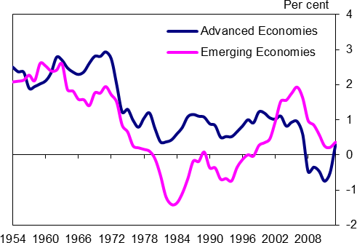

Source: Penn World Tables database.

Notes: Percentage change in median TFP growth; five year moving average.

## Chart 9: Productivity trends across individual countries

* 1. Advanced economies:

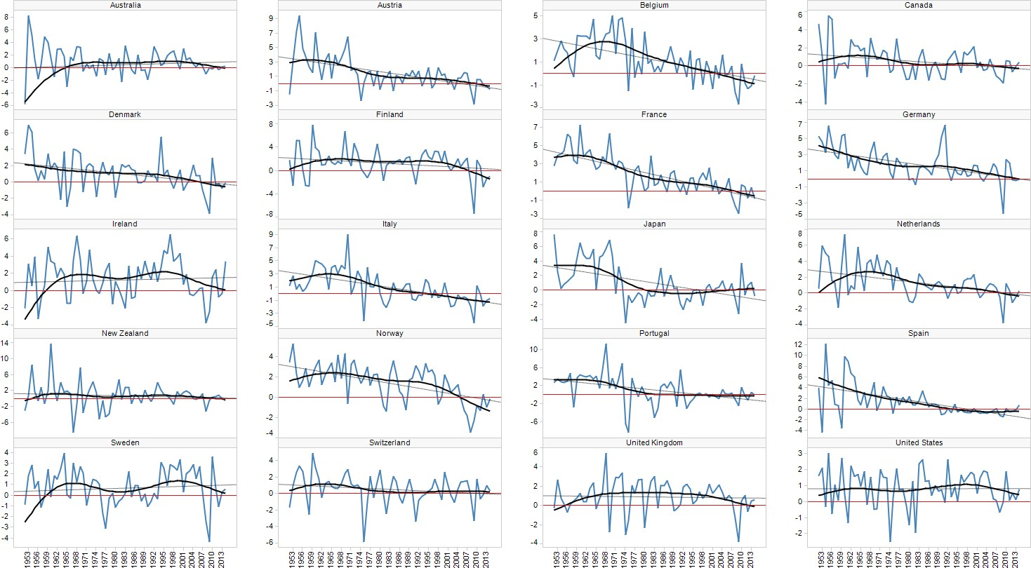

Emerging markets:

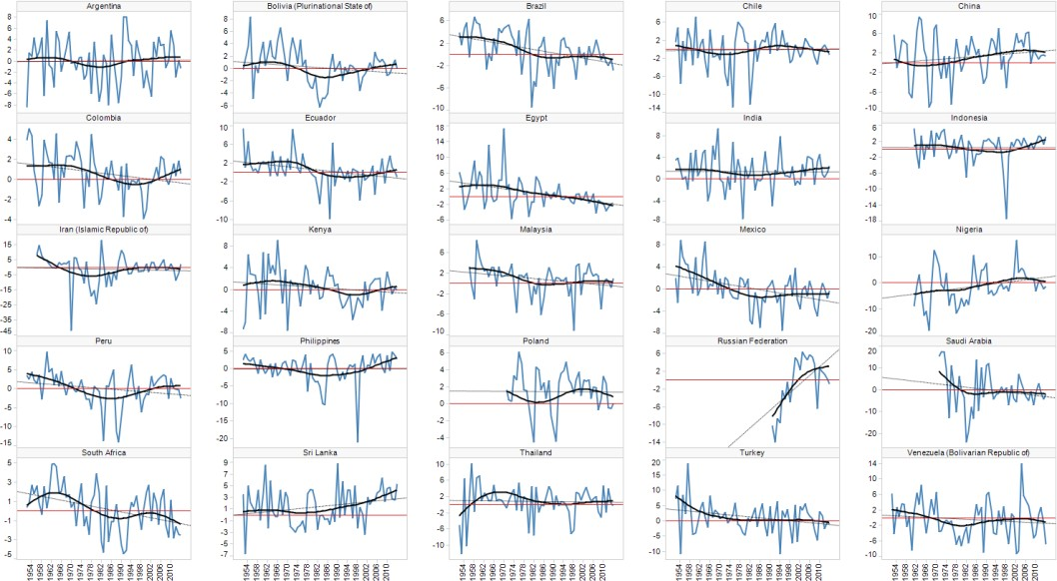

Source: Penn World Tables 9.0 and Bank calculations.

Notes: Percentage change in TFP growth; trend lines show HP filter.

## Chart 10: Distribution of productivity levels across 44 countries relative to the US

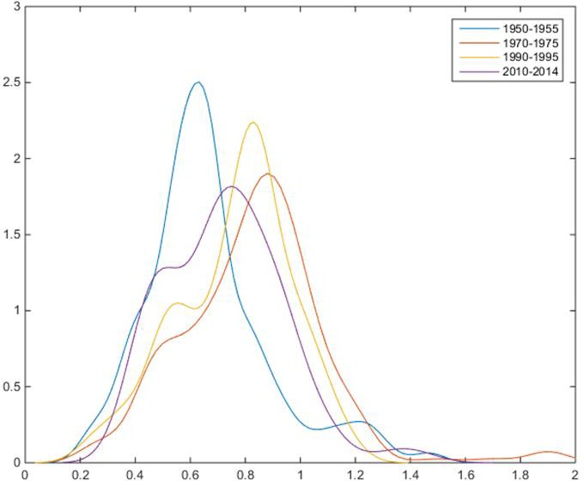

Source: Penn World Tables 9.0 and Bank calculations.

Notes: Median TFP level at current PPPs; US TFL level = 1; sample of 44 countries.

## Chart 11: Productivity level relative to the US, by region

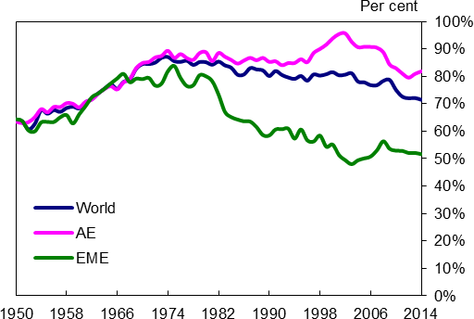

Source: Penn World Tables 9.0 and Bank calculations. Notes: Median TFP level at current PPPs; USA = 1.

## Chart 12 – Convergence coefficient

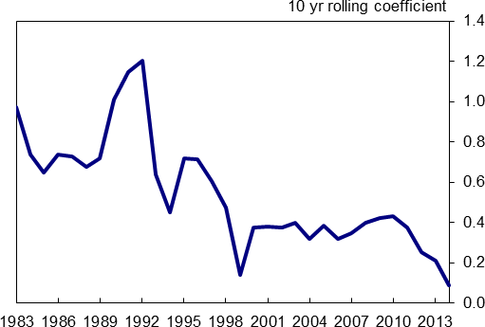

Source: Penn World Tables 9.0 and Bank calculations.

Notes: The coefficient can be interpreted as follows: for every 10ppt TFP gap compared to the US, TFP growth is x percentage points faster than in the US.

## Chart 13: Productivity across sectors

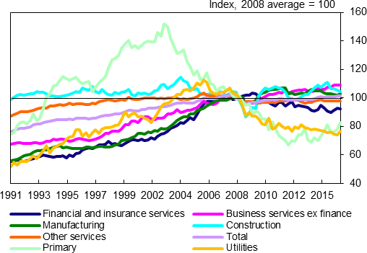

Source: ONS and Bank calculations.

## Table 2: Contributions to annual labour productivity growth

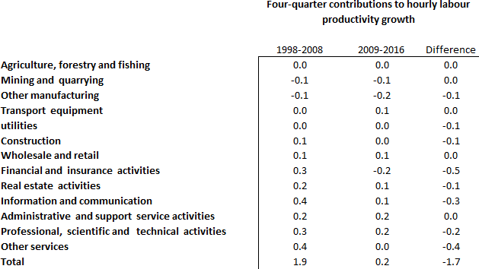

Source: ONS and Bank calculations.

## Chart 14: The standard deviation of productivity across industries

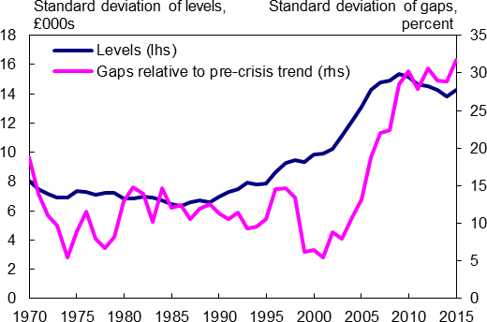

Source: EUKlems productivity database, ONS and Bank calculations.

Notes: The chart excludes the mining & extraction, energy and real estate industries.

## Chart 15: The variance of productivity within and across industries

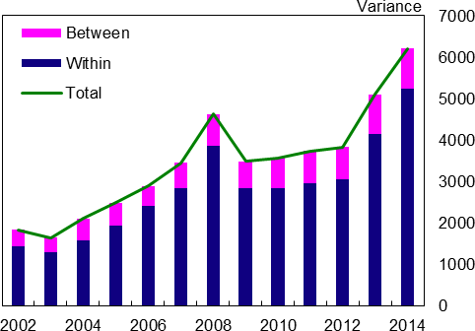

Source: ONS Research Database and Bank calculations.

Notes: This work contains statistical data from the ONS which is Crown Copyright. The use of the ONS statistical data in this work does not imply the endorsement of the ONS in relation to the interpretation or analysis of the statistical data. This work uses research datasets which may not exactly reproduce National Statistics aggregates. This note applies to all charts and analysis using data from the ONS Research Database.

## Chart 16: The distribution of productivity across firms

|  |  |
| --- | --- |
| **(a) Distribution in 2014** | **(b) Lower tail of distribution in selected years** |

Density

|  |  |
| --- | --- |
|  | 2014 |
|  |  |

-50 0 50 100 150 200

GVA per worker, £000s

0.016

0.014

0.012

0.01

0.008

0.006

0.004

0.002

0

-0.002

-50 -30 -10 10

GVA per worker, £000s

Density

0.02

2002

2008

2014

0.018

0.016

0.014

0.012

0.01

0.008

0.006

0.004

0.002

0

-0.002

Source: ONS Research Database and Bank calculations. Notes: Gross value added per worker.

## Chart 17: Firm level productivity distribution over time

|  |  |
| --- | --- |
| **(a) Levels** | **(b) Index** |

GVA per person, £th

140

25th percentile

75th percentile

10th percentile 50th percentile

90th percentile

120

100

80

60

40

20

0

GVA per person, Index 2002 =100

180

10th percentile 50th percentile 90th percentile

25th percentile

75th percentile

160

140

120

100

80

60

40

20

0

2002 2004 2006 2008 2010 2012 2014

2002 2004 2006 2008 2010 2012 2014

Source: ONS Research Database and Bank calculations. Notes: Productivity per worker.

## Chart 18: Productivity among Frontier and Non-Frontier companies

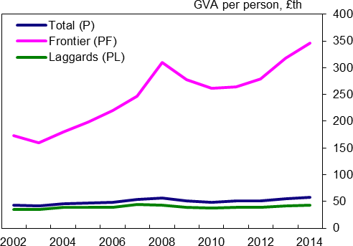

Source: ONS Research Database and Bank calculations.

Notes: Frontier defined as top 5% of firms by GVA per worker in a given year and sector as defined by 2-digit SIC 2007 industrial classification.

## Chart 19: Contribution of frontier and other firms to productivity growth

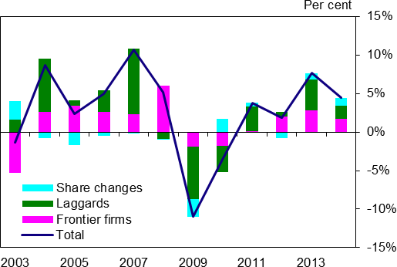

Source: ONS Research Database and Bank calculations. Notes: Frontier as defined in **Chart 18.**

## Chart 20: Productivity dispersion*

**(a) Services (Levels) (b) Manufacturing (Levels)**

Log (90/10) ratio

Denmark France Japan

New Zealand

Finland Italy Norway UK

5.0

Log (90/10) ratio

Denmark

France Japan

New Zealand

Finland

Italy Norway UK

3.0

4.0

3.0

2.0

2.0

1.0

1.0

2001

0.0

2003 2005 2007 2009 2011 2013 2015

2001

0.0

2003 2005 2007 2009 2011 2013 2015

# (c) Services (Index) (d) Manufacturing (Index)

Index, 0=2001

Denmark Finland France Italy Japan Norway

New Zealand UK

0.7

0.6

0.5

0.4

0.3

0.2

0.1

0.0

-0.1

-0.2

0.7

0.6

Index, 0=2001

Denmark Finland

France

Italy Japan

Norway

New Zealand UK

0.5

0.4

0.3

0.2

0.1

0.0

-0.1

-0.2

2001 2003 2005 2007 2009 2011 2013 2015 2001 2003 2005 2007 2009 2011 2013 2015

Source: OECD and Berlingieri, Blanchenay and Criscuolo (2017, forthcoming); ONS Research Database and Bank calculations. Notes: Charts a and b show the log difference between the 90th and 10th percentiles; Charts c and d show the same data indexed to zero in 2001. UK data only available from 2002, UK index base year = 2002. Data have been aggregated from a detailed industry level.

To the extent that industry classifications in the UK and the other countries shown are slightly different this may affect the comparability of the series. Please note that the y-axis label for Charts 20a and 20b have been amended since this speech was originally published.

## Chart 21: Management practices and labour productivity

Density

0.6

0.5

0.4

0.3

Management score

Labour productivity

0.2

0.1

0

-4 -2 0 2 4

Z score

Source: BvD, World Management Survey and Bank calculations.

Notes: The productivity kernel is based on around 280,000 firm-year observations on labour productivity (in logs) spanning the 2002- 2013 period (source: BVD). The management kernel is based on around 1500 interviews with firm managers from the WMS database (as described in Bloom and Van Reenen, 2007, 2010). Covering the 2002-2014 period. The raw data are converted to Z-scores by removing the sample mean from each observation and dividing the demeaned values by the sample standard deviation.

## Chart 22: Firm level productivity distributions

Density

0.03

nufacturing nstruction

olesale and retail trade nsportation and storage rmation and communication

|  |  |
| --- | --- |
| **a) Region**  North East  Yorkshire & Humberside West Midlands  London  South West Scotland | **b) Industry**  North West Ma  East Midlands Co  East of England Wh  South East Tra  Wales Info  Pro |

fessional, scientific and technical activities

Density

0.025

0.02

0.01

0.02

0.015

0.01

-20

30 80 130 180

GVA per employee, £000's

0

-0.01

-50 0 50 100 150 200 250

GVA per worker, £000s

0.005

0

-0.005

**c) Export status d) Foreign ownership**

Density

Non exporter Exporter

-50 50 150 250

GVA per worker, £000s

0.018

0.016

0.014

0.012

0.01

0.008

0.006

0.004

0.002

0

-0.002

Density

Domestic

Foreign

-50 50 150 250 350

GVA per worker, £000s

0.016

0.014

0.012

0.01

0.008

0.006

0.004

0.002

0

-0.002

**e) Innovation f) Size**

Density

Innovators

Non-innovators

-50 0 50 100 150 200

GVA per worker, £000s

0.016

0.014

0.012

0.01

0.008

0.006

0.004

0.002

0

-0.002

Density

Small Medium Large

-50 0 50 100 150 200 250

GVA per worker, £000s

0.016

0.014

0.012

0.01

0.008

0.006

0.004

0.002

0

-0.002

## g) Leverage

Density 0.035

Low leverage

High leverage

0.030

0.025

0.020

0.015

0.010

0.005

0.000

-50 0 50 100 150

GVA per worker, £000s

Source: ONS, ONS Research Database, BvD and Bank calculations.

Notes: These charts plot the kernel density distribution of labour productivity (real GVA per employee) across Great Britain. Chart (e) uses unweighted firm data. Chart (g) shows data BvD rather than VML firm-level data and is not directly comparable to the other charts.

## Chart 23 – Firm exports and productivity

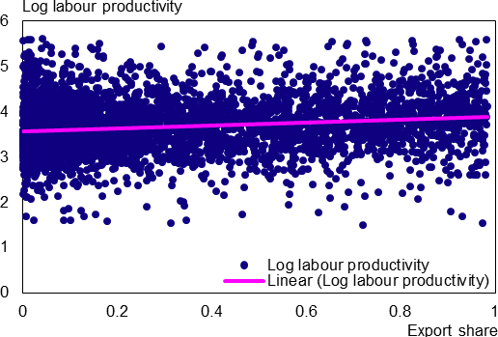

Source: BvD and Bahaj, Foulis, Gal and Pinter (2016).

Notes: Results from a Pooled Regression (slope=0.34; t-value=12.2), data for 2013.

## Table 3 – Median productivity growth by firm size*

|  |  |
| --- | --- |
| *Number of employees* | |
| 6-10 | 2.8 |
| 11-20 | 2.5 |
| 21-50 | 1.8 |
| >50 | 1.2 |

Source: BvD

Notes: Data for 1998 -2013; Three-year cumulative growth.

## Chart 24: Monetary policy counterfactual experiment based on company accounts data

|  |  |
| --- | --- |
| **a) Interest Cover Ratio** | **b) Leverage** |

-5 0

Interest cover ratio

Density

5 10 15

ICR = 1

Before intervention

After intervention

0.15

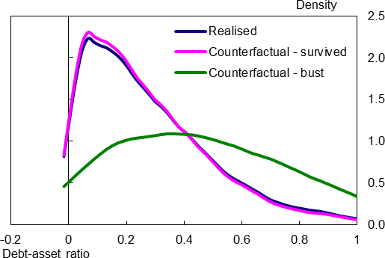0.10

0.05

0.00

|  |  |
| --- | --- |
| **c) Productivity – scenario 1** | **d) Productivity – scenario 2** |

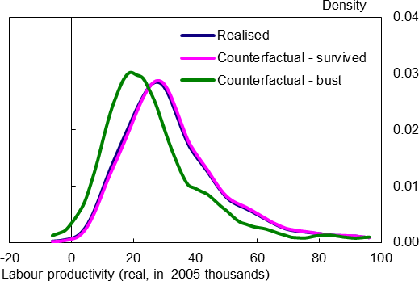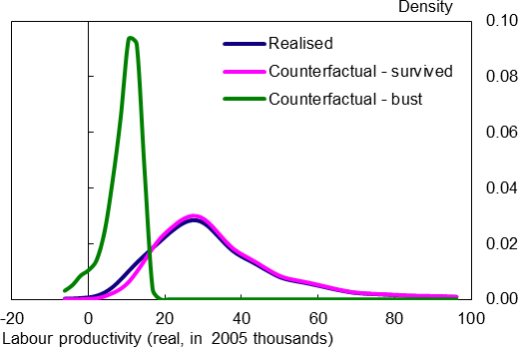

Source: BvD and Bank calculations.

Notes: Scenario 1 assumes that half of firms with interest cover ratios of less than 1 exit the market. In scenario 2, only the low- productivity half of firms with interest cover ratios of less than 1 exit the market.

## Chart 25: The estimated relationship between leverage and labour productivity

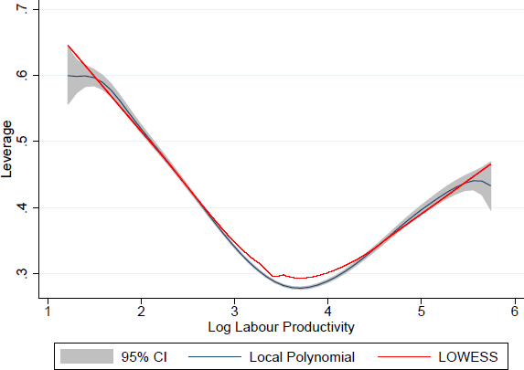

Source: Bahaj, Foulis, Gal and Pinter (2016).

Notes: The figure plots the results from local regressions. The red line shows the results from local weighted scatter smoothing (LOWESS), the blue line shows the results from a third degree kernel weighted local polynomial smoothing where the gray area depicts the associated 95% bootstrapped confidence bands. Labour productivity is defined as the log of gross value-added per number of employees. During the local regression estimations, we trim the data by deleting the top and bottom 1% of estimated productivity and leverage values in order to mitigate problems of outliers.

## Chart 26: Distribution of average pay across companies

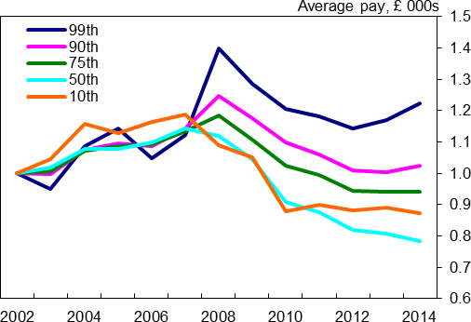

Source: ONS Research Database and Bank calculations. Notes: Series show wage deciles/percentiles.

## Chart 27: Distribution of firm level labour productivity, wages and profits in 2014

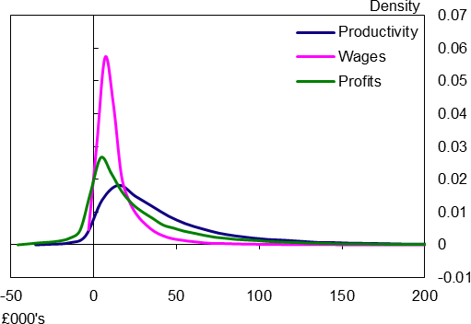

Sources: ONS Research Database and Bank calculations.

## Table 4: Regressions of average pay on productivity

|  |  |  |
| --- | --- | --- |
| Average pay | | |
|  | Levels | Growth |
| Productivity | 0.20*** | 0.49*** |
| Productivity2 | 0.04*** | 0.004 |
| Employment | 0.35*** | 0.14*** |
| Employment2 | -0.03*** | -0.005* |
| Age | 0.002*** | -0.002*** |
| Exporter | -0.005 | -0.03* |
| Foreign owned | 0.20*** | 0.09*** |
| Constant |  |  |
| Observations | 241,165 | 215,614 |
| R-squared | 0.60 | 0.51 |

Sources: ONS Research Database and Bank calculations. Notes: Regressions are in logs.

## Chart 28: Average and director pay from company accounts data

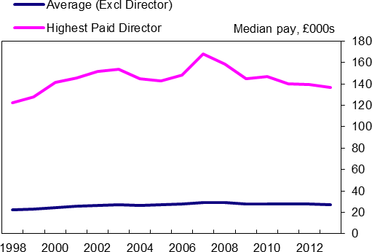

Sources: BVD.

## Chart 29: Variance of average and director pay from company accounts data

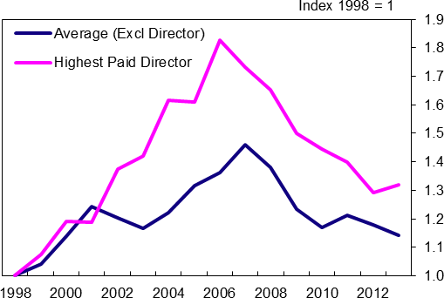

Sources: BvD.

## References

Aghion, P, T, Besley, J, Browne, D, Caselli, R, Lambert, R, Lomax, C, Pissarides, N, Stern, J, Van Reenen (2017) ‘Investing for Propsperity: skills, infrastructure and innovation’, *LSE Growth Commission Report*.

Amiti, M and D Weinstein (2013), How much do bank shocks affect investment? Evidence from matched bank-firm loan data’, *Federal Reserve Bank of New York Staff Reports 604*.

Andrews, D, Criscuolo, C and Gal, P (2015), ‘Frontier firms, technology diffusion and public policy: micro evidence from OECD’, *OECD Productivity Working Paper No 2*.

Arrowsmith, M, Franklin, J, Gregory, D, Griffths, M, Wohlmann, E and Young, G (2013), ‘SME forbearance and its implications for monetary and financial stability’, *Quarterly Bulletin*, Bank of England.

Bahaj, S, Foulis A, and Pinter, G (2016), ‘The Residential Collateral Channel’, *Discussion Paper 1607,*

Centre for Macroeconomics.

Bahaj, S, Foulis A, Gal, P and Pinter, G (2016), ‘Productive and Unproductive Leverage’, *mimeo,* Bank of England.

Baily, M and Montalbano, N (2016), ‘Why is productivity growth so slow? Possible explanations and policy responses’, *Hutchins Center Working Paper No 22*.

Barnett, A, Batten, S, Chiu, A, Franklin, J and Sebastiá-Barriel, M (2014), ‘The UK productivity puzzle’,

*Quarterly Bulletin, Vol 54 (2),* Bank of England.

Bank of England (2016), ‘Understanding and measuring finance for productive investment’, *Bank of England Discussion Paper*.

Barnett, A, Broadbent, B, Franklin, J and Miller, H (2014), ‘Impaired capital reallocation and productivity’,

*National Institute Economic Review*.

Barro, R and Sala i Martin, X (1992), ‘Convergence’, *The Journal of Political Economy, Vol 100 (2), p.223- 251.*

Bean, C (2016), ‘Independent Review of UK Economic Statistics’, available at [https://www.gov.uk/government/publications/independent-review-of-uk-economic-statistics-final-report.](https://www.gov.uk/government/publications/independent-review-of-uk-economic-statistics-final-report)

Bentolila, S, Jansen, M, Jimnez, G and Ruano, S (2013), ‘When credit dries up: job losses in the great recession’, *Discussion Paper 9776, CEPR*.

Berlingieri, G, Blanchenay, P and Criscuolo, C (2017), ‘The Great Divergence(s)’, *OECD STI Policy paper, forthcoming*.

Big Innovation Centre (2017a), ‘The Purposeful Company’, *BIC Policy Report, February*

Big Innovation Centre (2017b), “Intangible Gold” *final report, forthcoming*

Bloom N and Van Reenen, J (2007), ‘Measuring and explaining management practices across firms and countries’, *Quarterly Journal of Economics, Vol CXXII (4)*.

Bloom, N, Sadun, R and Van Reenen, J (2012), ‘Americans Do IT Better: US Multinationals and the Productivity Miracle’, *American Economic Review No 102 (1), p167–201, doi:10.1257/aer.102.1.167*.

Blundell, R, Crawford, C, Jin, W (2013), ‘What can wages and employment tell us about the UK’s productivity puzzle?’, *IFS Working Paper W13/11*.

Broadbent, B (2012), ‘Productivity and the allocation of resources’, *Bank of England, speech at Durham Business School, available at* <http://www.bankofengland.co.uk/archive/Documents/historicpubs/speeches/2012/speech599.pdf>

Bryson, A, Forth, J and Askenazy, P (2014), ‘Productivity Puzzles in Europe: a Comparison of the UK, France, Germany and Spain’, *presented at the NIESR ‘Productivity and Firm Growth’ conference*.

Brynjolfsson, E and McAfee, A (2011), ‘Race against the machine: how the digital revolution is accelerating innovation, driving productivity and irreversibly transforming employment and the economy’, *Digital Frontier Press Lexington, Massachusetts*.

Brynjolfsson, E and McAfee, A (2014), ‘The Second Machine Age: work, progress and prosperity in a time of brilliant technologies’, *Norton and Company, New York*.

Byrne, D, Fernald, J, Reinsdorf, M (2016), ‘Does the United States have a productivity slowdown or a measurement problem?’, *Brooking Papers on Economic Activity, Spring*.

Calligaris, S, Del Gatto, M, Hassan, F, Ottaviano, G and Schivardi, F (2016) ‘Italy’s productivity conundrum: A study on resource misallocation in Italy’, *European Economy Discussion Paper No 30, European Commission*.

Chodorow-Reich, G (2014), ‘The employment effects of credit market disruptions: Firm-level evidence from the 2008-09 financial crisis’, *The Quarterly Journal of Economics, Vol 129 (1)*.

Comin, D and Mestieri, M (2013), ‘Technology diffusion: measurement, causes and consequences’, *NBER Working Paper No. 19052*

Cowen, T (2011), ‘The great stagnation: How America ate all the low-hanging fruit of modern history, got sick and will (eventually) feel better’, *Penguin eSpecial:Dutton, New York*.

Dabla-Norris, E, S, Guo, V, Haksar, M, Kim, K, Kochhar, K, Wiseman and A, Zdzienicka (2015), ‘The new normal: a sectoral-level perspective on productivity trends in advanced economies’, *IMF Staff Discussion Note,SDN/15/03*.

Disney, R, Jin, W and Miller, H (2013), ‘The productivity puzzles’, *IFS Green Budget*.

Edgerton, J (2012), ‘Credit supply and business investment during the great recession: Evidence from public records of equipment financing’, *mimeo, Federal Reserve Board*.

Feenstra, R, Inklaar, R and Timmer, M (2015), ‘The Next Generation of the Penn World Table’, American

*Economic Review, Vol 105(10), p.3150-3182*, available for download at [www.ggdc.net/pwt.](http://www.ggdc.net/pwt)

Feldstein, M (2016), ‘Remarks at the Brookings Institution conference on productivity’, 8 September, available at <https://www.brookings.edu/wp-content/uploads/2016/08/feldstein-remarks.pdf>.

Foda, K (2016), ‘The productivity slump; a summary of the evidence’, *Global Economy and Development at Brookings Brief*.

Franklin, J, Rostom, R and Thwaites, G (2015), ‘The banks that said no: banking relationships, credit supply and productivity in the United Kingdom’, *Bank of England Staff Working Paper No 557*.

Furman, J and Orszag, P (2015), ‘A Firm-Level Perspective on the Role of Rents in the Rise in Inequality’, Presentation at “A Just Society” Centennial Event in Honor of Joseph Stiglitz.

Gopinath, G, Kalemli-Ozcan, S, Karabarbounis, L Villegas-Sanchez, C (2015), ‘Capital Allocation and Productivity in South Europe’, *NBER Working Paper No. 21453*.

Gordon, R (2012), ‘Is the US economic growth over? Faltering innovation confronts the six headwinds’,

*NBER Working Paper No. 18315*, available at [http://www.nber.org/papers/w18315.](http://www.nber.org/papers/w18315)

Gordon, R (2014), ‘The demise of US economic growth: restatement, rebuttal and reflections’, *NBER Working Paper No. 19895*.

Gorton, G and Ordonez, G (2015), ‘Good Booms, Bad Booms’, Manuscript, *University of Pennsylvania*.

Greenstone, M and Mas, A (2012), ‘Do credit market shocks affect the real economy? Quasi-experimental evidence from the great recession and 'normal' economic times’, *Technical Report 12-27, MIT Department of Economics Working Paper*.

Haldane, A, Brennan, S, and Madouros, V (2010), ‘What is the contribution of the financial sector: miracle or mirage?’, in Turner A and others, *The Future of Finance: The LSE Report*, London School of Economics and Political Science.

Haldane, A (2016), ‘One car, two car, red car, blue car’ Speech given at Materials Processing Institute, 2 December.

Haskell, J and Westlake, S (2016), ‘Are intangibles worsening the productivity gap between leading firms and laggards?’, *2 June, blog post* available at [http://www.theintangibleeconomy.com/.](http://www.theintangibleeconomy.com/)

Helpman, E and Trajtenberg, M (1998), ‘A Time to Sow and A Time to Reap: Growth Based on General Purpose Technologies’ in Elhanan Helpman, (ed.) *General Purpose Technologies and Economic Growth, MIT Press*.

Hsieh, C and Klenow, P (2009), ‘Misallocation and manufacturing TFP in China and India’, *Quarterly Journal of Economics, Vol* 124(4), p.1403-1448.

Hoekman, B, K, Maskus, K, Saggi (2004), ‘Transfer of technology to developing countries: unilateral and multilateral policy options’, *Institute of Behavioural Science Working Paper PEC2004-0003*.

HM Government (2017), ‘Building our Industrial Strategy’, *HM Government Green Paper*

HM Treasury and Department for Business (2017), ‘Patient capital review’, *UK Government Policy Paper, February*

Mayfield, C (2016), ‘How good is your business really? Raising our ambitions for business performance’,

*available at:* <https://howgoodisyourbusinessreally.co.uk/>

McGowan M, Andrews D and Valentine M (2017), ‘The walking dead? Zombie firms and productivity performance in OECD countries’, *OECD Economics Department Working Papers No 1372*.

McCafferty, I (2014), ‘The UK productivity puzzle – a sectoral perspective’, *speech given at Market News, London, 19 June*.

McMillan, M and Rodrik, D (2011), ‘Globalisation, structural change and productivity growth’, *National Bureau of Economic Research Working Paper No 17143*.

Melitz, M (2003), ‘The impact of trade on intra-industry reallocations and aggregate industry productivity’,

*Econometrica, Vol 71(6),* p.1695-1725.

Mokyr, J (2014a), ‘What today’s economic gloomsayers are missing’, *Wall Street Journal, 8 August*.

Mokyr, J (2014b), ‘The Next Age of Invention: Technology’s future is brighter than pessimists allow’, in Brian C.

Newman, C, J, Rand, T Talbot and D Tarp (2015), ‘Technology transfers, foreign investment and productivity spillovers’, European Economic Review, March.

Reis, R (2013), ‘The Portuguese Slump and Crash and the Euro Crisis’, *Brookings Papers on Economic Activity, Vol 46(1),* p.143-193.

Paravisini, D, Rappoport, V, Schnabl, P and Wolfenzon, D (2015), ‘Dissecting the effect of credit supply on trade: Evidence from matched credit-export data’, *The Review of Economic Studies, Vol 82(1),* p.333-359.

Piketty, T (2014), ‘Capital in the twenty-first century’, *Harvard University Press*.

Riley, R, Rosazza Bondibene, C and Young, G (2015), ‘The UK Productivity Puzzle 2008-2013: Evidence From British Businesses’, *NIESR Discussion Paper*.

Rodrik, D (2011), ‘The future of economic convergence’, *Harvard Kennedy School Faculty Research Working Paper, RWP 11-033*.

Billett, I and Schneider, P (2016), ‘Bitesize: Exploring UK sectoral productivity’, *Bank Underground blog post*, available at [https://bankunderground.co.uk/2017/01/19/bitesize-exploring-uk-sectoral-productivity/.](https://bankunderground.co.uk/2017/01/19/bitesize-exploring-uk-sectoral-productivity/)

Song, J, Price, D, Guvenen, F, Bloom, N and Von Wachter, T (2015), ‘Firming Up Inequality’, *NBER Working Paper No. 21199*.

Stoyanov, A, and Zubanov, N (2012), ‘Productivity spillovers across firms through worker mobility’, *American Economic Journal: Applied Economics,* p.168-198.

Summers, L (2013), IMF Fourteenth Annual Research Conference in Honor of Stanley Fischer, 8 November.

Syverson, C (2016), ‘Challenges to Mismeasurement Explanations for The U.S. Productivity Slowdown’,

*NBER Working Paper No. 21974*.

Tuuli, S and Batten, B (2015), ‘Back to the future: why we’re optimistis in the secular stagnation debate’, *Bank Underground Blog post*, July, available at [https://bankunderground.co.uk/2015/07/02/supply-side-](https://bankunderground.co.uk/2015/07/02/supply-side-secular-stagnation-and-the-future-of-innovation/) [secular-stagnation-and-the-future-of-innovation/.](https://bankunderground.co.uk/2015/07/02/supply-side-secular-stagnation-and-the-future-of-innovation/)

Weale, M (2014), ‘The UK productivity puzzle: an international perspective’, *Speech to Mile End Group, Queen Mary, University of London, 8 December*.